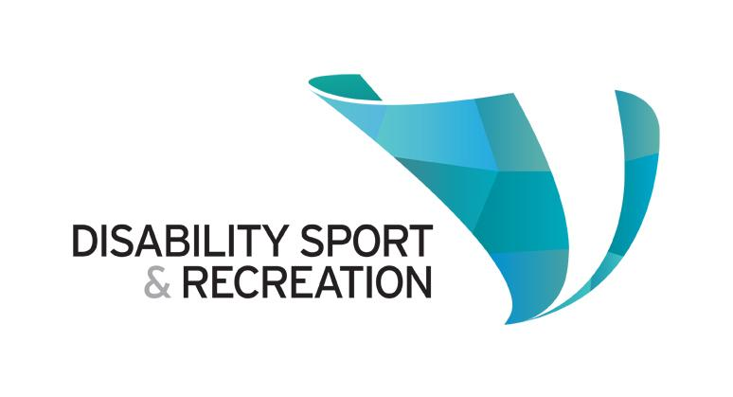

Disability Sport & Recreation Volunteer Handbook

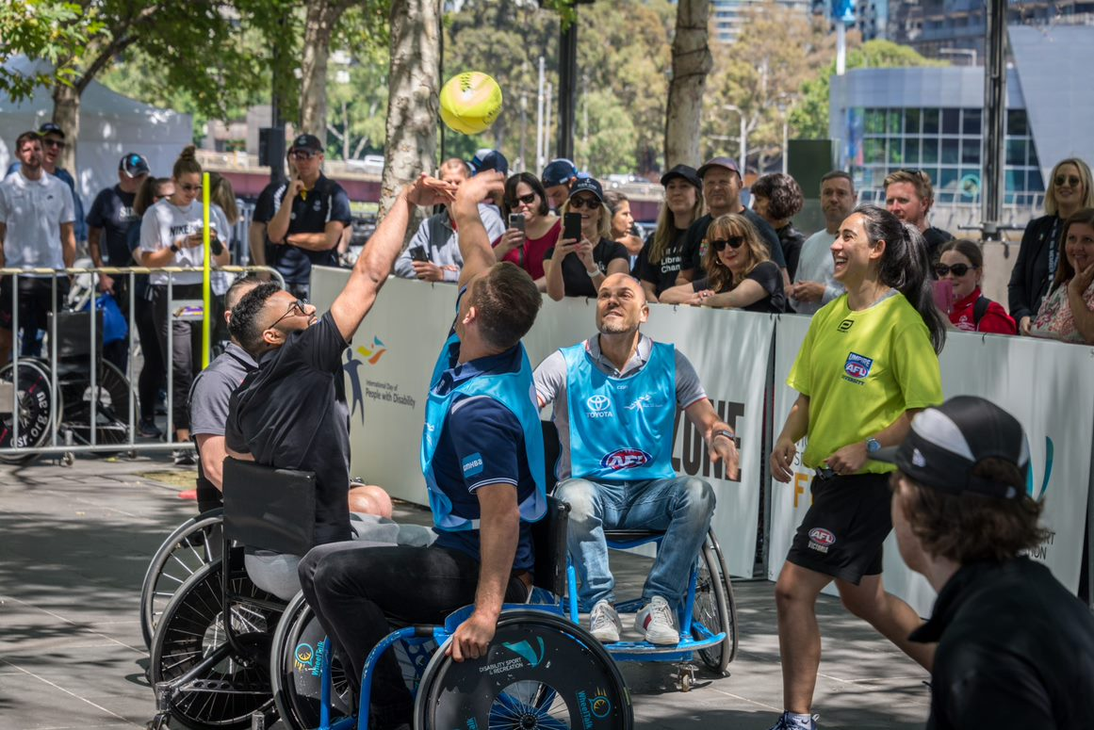

Contents

CEO welcome 3
About this handbook 4
Our vision, mission and values 4
About us 5
Volunteer vision 6
Your rights and responsibilities 8
Our responsibilities 9
Our volunteer code of practice 10
Volunteer guidelines 11

CEO welcome
It is my pleasure to introduce you to Disability Sport & Recreation. We recognise the role of volunteers, their value and the contribution they make to our organisation and, more importantly, the community.
Volunteers play a key role within our organisation. We encourage the recruitment and training of volunteers to help with administration, fundraising and communications as well as volunteering at events and on our camps.
Our willingness to embrace volunteerism and involve volunteers in our programs and services, demonstrates our commitment to community engagement and making sure Victorians with disability have equal opportunities to take part in the sport and recreation activities they want to.
It’s true that we can’t provide our level of service without our volunteers.
This handbook gives you general information relevant to volunteers across all our programs. I sincerely hope your time with us is enjoyable, rewarding and meets your expectations.

Richard Amon
Chief Executive Officer

About this handbook
Volunteers are valued members of our community who kindly donate their support and time to DSR.
Becoming a volunteer opens a world of opportunity for you to learn new skills, develop self-confidence, connect with others, give back and enjoy yourself. It is your chance to be involved in your community in a way that is interesting, satisfying and fun.
Volunteering can be formal or informal, short-term, long-term or even a one off.
We have developed this handbook to guide you on your volunteer journey with us, as we want you to have the best experience that you can with DSR.

Our vision, mission and values
Our vision
A Victoria where all people with disability can choose and access any sport or active recreation they want to engage with.
Our mission
To provide and promote positive health outcomes for people with disability, through meaningful engagement in sport and active recreation.
Our values
We are friendly, accountable, open, respectful, appreciative and progressive.

About us
In 1962, the ParaVics Sports Club was formed to help a group of eight athletes with disability compete in national and international sporting competitions. The club grew from the grassroots actions of a small group of athletes who were united by the ambition to compete in paraplegic sporting events at an international level.The club challenged preconceptions and dispelled societal prejudices toward disability in order to achieve this.
Transitioning to Wheelchair Sports Victoria, and later in 2010 to Disability Sport and Recreation, we now include all types of disability and recreational activities to ensure that people with disability can be part of their community in whatever activity they wish.
We are now the peak body for disability sport and recreation in Victoria.
Over this time, we have grown to help Victorians – from grassroots players to elite athletes – get active, play and compete in the sports and physical recreation activities that they love.
For more than 50 years, we have been able to help Victorians with disability get active thanks to the generous donations and support of the Victorian community.
We are proud to be the birthplace of the Victorian Paralympic movement.

Volunteer vision

We give our volunteers the opportunity to share their passions, abilities and skills in meaningful ways.

A volunteer is a person who:

- Benefits the community and themselves by taking part in volunteering programs.
- Provides services of their own free will.
- Does not receive any financial reward.
- Performs activities that complement, but does not replace, the services provided by paid staff.

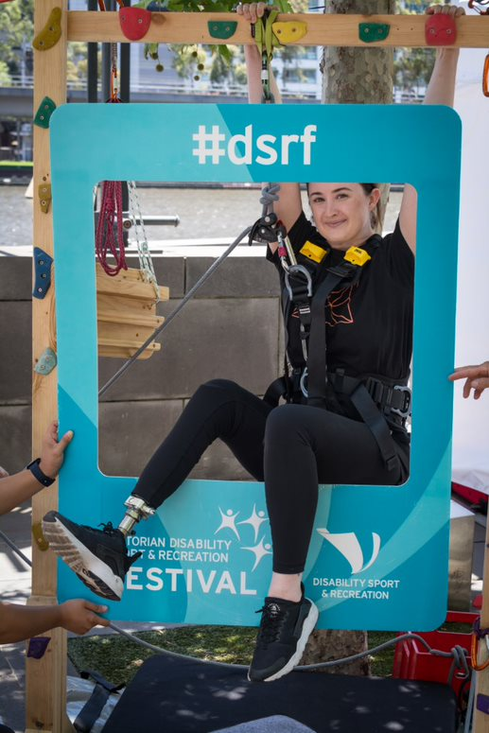

We support volunteering because it:

- Strengthens the bonds between our organisation and the community we work in, resulting in better outcomes for people with disability.
- Gives community members the opportunity to actively take part and contribute their unique talents, skills and knowledge, enhancing their personal development and self-esteem.
- Facilitates innovation by directly involving people with disability along with their family and carers.
- Provides rewarding opportunities to people in the community who share our vision, mission and values of transforming the lives of Victorians with disability through sport and recreation.

Benefits of volunteering:

- Acting on your values, passions and interests.
- Meeting new people, making new friendships and expanding your professional networks.
- Being involved in activities and programs that make a real difference to people
with disability.
- Gaining new skills and experience in an area of interest that can create pathways
to employment.
- Increasing your confidence.
- Being part of a team.
- Contributing to the wellbeing and development of people with disability.
- Enjoy better physical and mental health as studies have shown that volunteering makes us healthier and happier!

Your rights and responsibilities
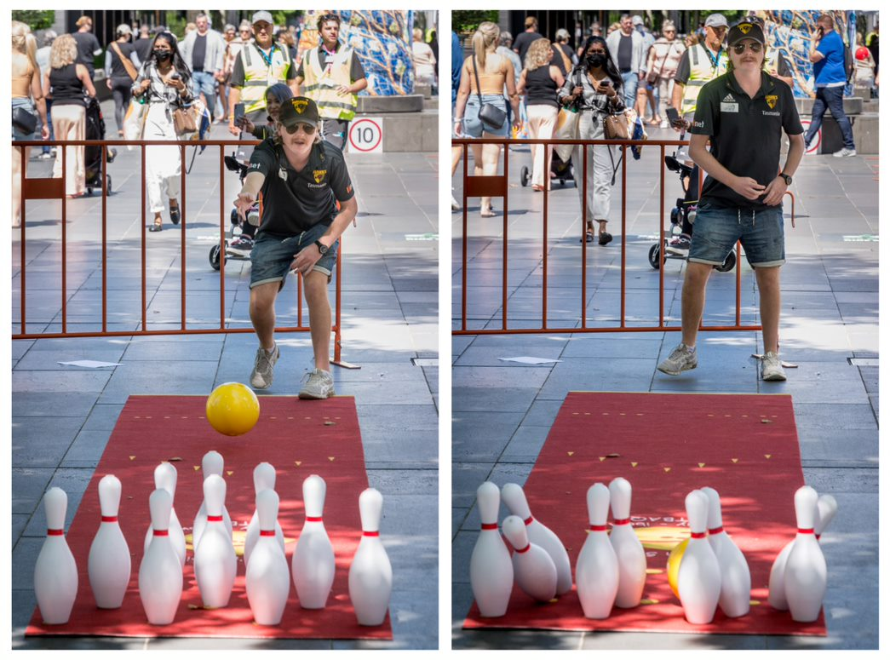

As a volunteer, you have the right to:
- Be given an induction, have clarity of your role and support from staff and managers.
- Know about DSR and the way the volunteer program operates.
- Understand how to give feedback, including how to make a complaint.
- Be informed of any new developments of your role, before any changes are implemented.
- Find enjoyment and satisfaction in your role.
- Work in a safe environment where you feel respected and welcomed.
- Contribute ideas.
- Be allocated suitable tasks that are within your skill range.
- Be protected from excessive demands and have the ability to turn down work.
- Be treated fairly and respectfully and be valued as an important member of our team.

Your responsibilities
- Understand and meet the requirements of relevant policies and procedures.
- Take part in all requires induction, work health and safety training programs.
- Operate under the direction and guidance of your nominated supervisor to
complete tasks.
- Let your supervisor know about any hazards or situations that may be a health or safety risk to yourself or others.
- Use any safety equipment we provide you with and report any accidents or incidents to your supervisor.

Our responsibilities

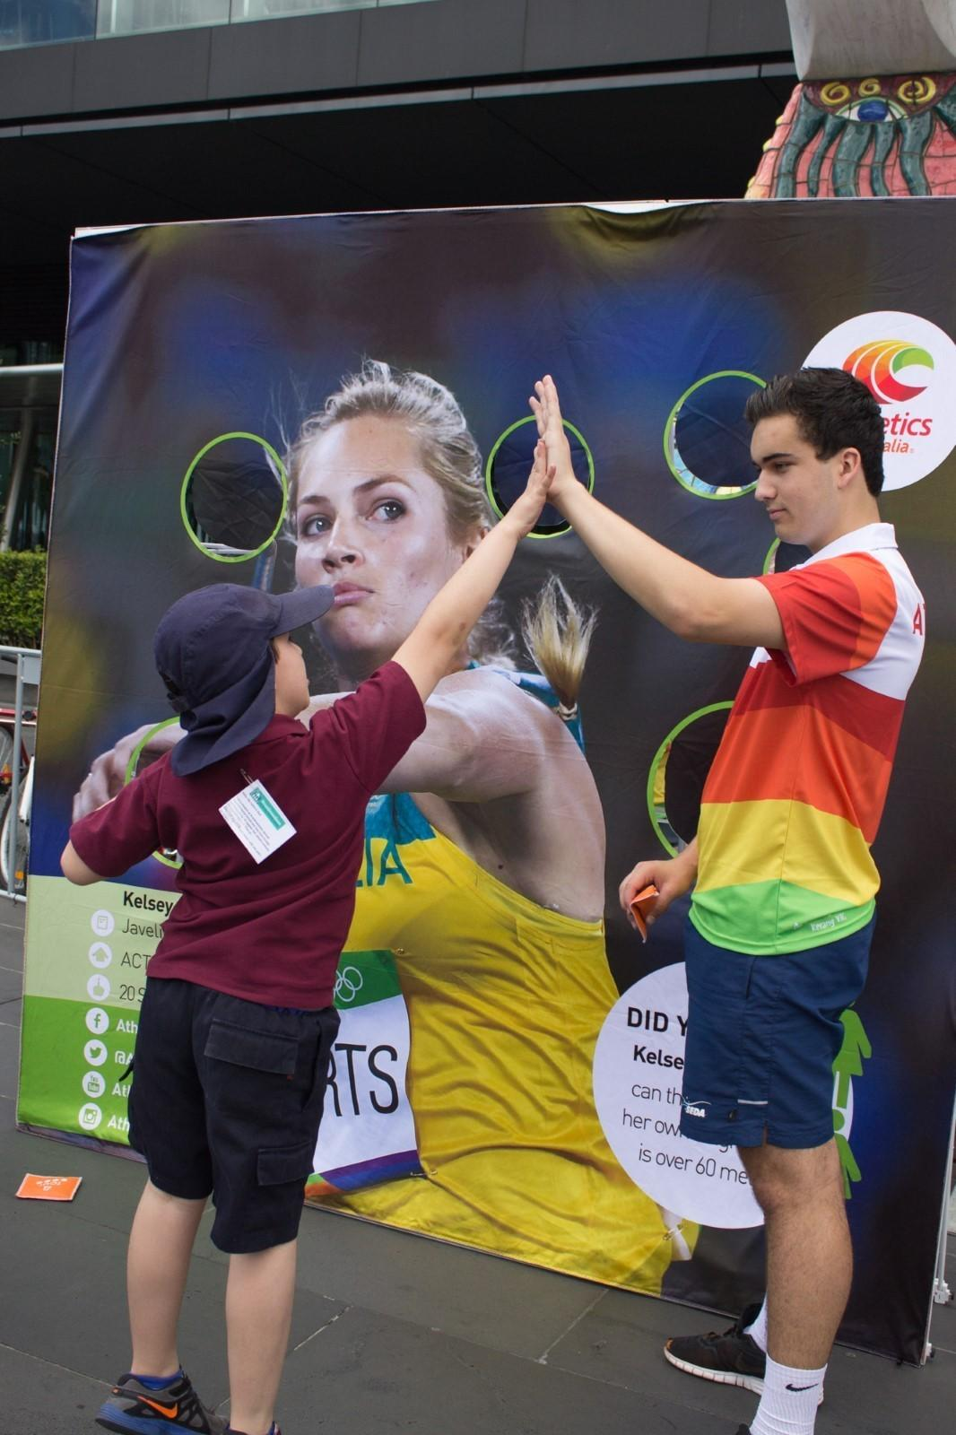

Our responsibilities
- Recognise the different roles, rights and responsibilities of volunteers.
- Create an environment of respect.
- Provide a safe and healthy working environment.
- Provide an induction and the training needed for you to carry out your role.
- Provide a clear outline of your volunteer duties, including documentation about the work to be done (including a position description).
- Provide supervision and support.
- Provide emergency procedure guidelines.
- Explain the process for making a complaint and conflict resolution procedures.
- Consult and communicate with volunteers when making decisions about their roles.

Our volunteer code of practice

We have a volunteer policy that recognises that every volunteer:
- Has the right to work in a safe environment.
- Will be free from discrimination and harassment.
- Will complete an induction process, which includes basic training.
- Will be supported by an appropriate member of staff.
- Will be matched with an appropriate opportunity.
- Will have regular meetings with their nominated supervisor.
- Will have access to a variety of training opportunities.

We will:
- Provide you with an induction to our organisation and your volunteer role.
- Give you training so you can perform in your role and tasks to the best of your ability.
- Offer you opportunities for professional development.
- Recognise you as a valuable team member and let you know about opportunities to take part in program decisions.
- Make sure we uphold the rights of volunteers.
- Acknowledge the valuable contribution made by volunteers.

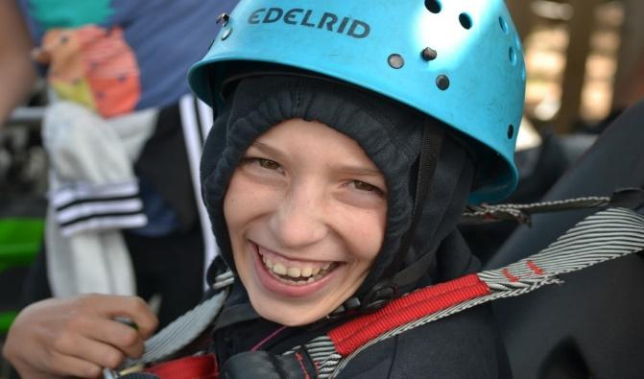

Volunteer guidelines

Volunteer induction and training
After we have received and reviewed your expression of interest, you will be invited to a volunteer induction and training session which will give you the knowledge and skills necessary for our volunteer program. We will also cover any policies and procedures that are relevant to your volunteer role.
You will be asked to sign a volunteer engagement agreement. This agreement will confirm that you understand the terms and conditions of your involvement with DSR.
Lastly, we will provide you with a tour of our building and an opportunity to meet any staff and other volunteers that you will be working with.
Police Check
Before volunteering with us, you will need to undergo a National Police Check. This is to confirm your identity and minimise the risk of engaging volunteers that are not appropriate for DSR. We will pay for the check.
Working with Children Check
You will also need to get a Working with Children Check before volunteering with us. Applying for the check is free if you indicate that you are a volunteer.
Expenses
While a fundamental component of volunteering is that you don’t receive payment for your time, you will be reimbursed for out-of-pocket expenses. No volunteer will be financially worse off as a result of their volunteering duties.
The procedure for reimbursement will be discussed as part of your induction.
Safety, wellbeing and security
We provide a healthy and safe workplace for everyone – both volunteers and staff. As part of your induction to a volunteer role, we will ask you to meet the requirements of all relevant OHS policies and procedures.
Manual handling
We encourage staff and volunteers to follow the correct manual handling policy procedures in the workplace to avoid strains and injury.

Fair treatment and the Equal Opportunity Act 2010
Equal Opportunity
Everyone has the right to be protected from bullying, harassment and discrimination at work. Equal Opportunity law and associated legislation puts provisions in place to ensure that all staff, volunteers, agency personnel and work experience students are protected.
Discrimination
Discrimination occurs when someone takes adverse action against someone else because of a protected attribute.
Protected attributes in the Equal Opportunity Act are:
- age
- parent and carer status
- disability
- employment activity
- expunged homosexual conviction
- gender identity
- industrial activity
- lawful sexual activity
- marital status
- physical features
- political belief or activity
- pregnancy and breastfeeding
- race
- religious belief or activity
- sex
- sexual orientation
- personal association with someone who has, or is assumed to have, one of these personal characteristics

We celebrate diversity and are firmly committed to creating an environment that is free from discrimination, sexual harassment, workplace bullying and victimisation.

Sexual harassment
Sexual harassment is an unwelcome sexual advance, unwelcome request for sexual favours or other unwelcome conduct of a sexual nature that makes a person feel offended, humiliated and/or intimidated, where a reasonable person would anticipate that reaction in the circumstances.
The Sex Discrimination Act 1984 (Cth) defines the nature and circumstances in which sexual harassment is unlawful. It is also unlawful for a person to be victimised for making, or proposing to make, a complaint of sexual harassment to the Human Rights and Equal Opportunity Commission.

Workplace bullying
Everyone has the right to a workplace free from bullying.
Bullying is repeated and unreasonable behaviour that creates a risk to health and safety.
Bullying behaviour may take the following forms:
- aggressive or intimidating conduct
- belittling or humiliating comments
- spreading malicious rumours
- teasing, practical jokes or ‘initiation ceremonies’
- exclusion from work-related events
- unreasonable work expectations, including too much or too little work, or work below or beyond a worker’s skill level
- displaying offensive material
- pressure to behave in an inappropriate manner
Bullying occurs when:
- a person (or a group) repeatedly behaves unreasonably towards a worker (or a group) at work, AND
- that unreasonable behaviour creates a risk to health and safety.
Smoking, alcohol and other drugs
DSR has a strict policy to ensure the health and wellbeing of staff, contractors, visitors and volunteers, as required by the Occupational Health and Safety Act 2004 (VIC).

Privacy
Whilst we require certain personal information from you, such as your contact details and emergency contact details, we will not share this with a third party.
What do we expect of you?
- Be reliable, honest and respect confidentiality.
- Listen to, support and encourage others and contribute to their development.
- Promote the aims and objectives of our organisation and carry out tasks in a
way that contributes to the values of our organisation.
- Immediately contact your supervisor if you have any concerns about your
volunteer work.
- If you receive a gift that is valued over $20 from a supplier, partner or member while carrying out your volunteer role, you must give this gift to your supervisor. The gift will become a ‘donated good’. We do not encourage gifts from external parties.

Inappropriate Conduct
If you display unacceptable behaviour, we may end your volunteer position. Serious breaches include:
- Deliberately vandalising, sabotaging or damaging Disability Sport &
Recreation property.
- Physically, psychologically or verbally abusing another volunteer, staff, member, tenant, sponsor, partner or member of the public.
- Discriminating against, or giving preference to, any person wishing to use
our services.
- Breaching the confidentiality of our organisation, staff, member, partnership and sponsor information.
- Being under the influence of alcohol or drugs while volunteering for us.
- Stealing property that belongs to Disability Sport & Recreation, staff, members, tenants or other volunteers.
Ending your time with us
You can leave your volunteer position at any time.
A verbal agreement should be reached with your supervisor as to the exact date that your volunteer role will end.
We will request that you complete an evaluation form to give us feedback on your experiences. This will help us to shape and improve future volunteer experiences.
